|  |  |  |  |  |
| --- | --- | --- | --- | --- |
| **National University of Computer and Emerging Sciences, Lahore Campus** | | | | |
| C:\Users\saif\AppData\Local\Microsoft\Windows\Temporary Internet Files\Content.Word\final design.jpg | **Course Name:** | **Design and Analysis of Algorithms** | **Course Code:** | **CS2009** |
| **Degree Program:** | **BSCS** | **Semester:** | **FALL 2022** |
| **Due Date:** | **Thursday, February 16, 2023** | **Total Marks:** | **10 + 10 + 10 = 30** |
| **Section:** | **4B** | **Page(s):** | **2** |
| **Exam Type:** | **Assignment 1** |  |  |
| **Student : Name:_____________________________ Roll No.________________ Section:_______** | | | | |
| **Instruction/Notes:** |  | | | |

**Loop invariants**

Use loop invariants to prove the correctness of the following algorithms

Note: Use the code given in this assignment.

1. Find Min

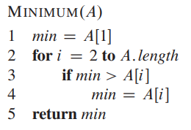

1. Bubble Sort

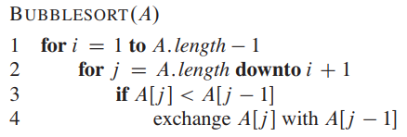

1. Selection Sort

SELECTIONSORT(*A*)

1. **for $j=1 to A.length-1$**
$smallest_index =j$

3. **for $i=j+1 to A.length$**
4. **if $A\left[i\right]<A[smallest_index]$**

$smallest_index=i$

$exchange A\left[j\right] with A[smallest_index]$